***Solution Section* 1.8 – Exponential Models**

***Exercise***

Find the derivative of 

***Solution***











***Exercise***

Find the derivative of 

***Solution***





***Exercise***

Find the derivative of 

***Solution***

|  |  |
| --- | --- |
|  |  |

***Exercise***

Find the Derivative of 

***Solution***









***Exercise***

Find the Derivative of 

***Solution***





















***Exercise***

Find the derivative of 

***Solution***







***Exercise***

Find the derivative of 

***Solution***



***Exercise***

Find the derivative of 

***Solution***







***Exercise***

Find the derivative of 

***Solution***







***Exercise***

Find the derivative of 

***Solution***







***Exercise***

Find the derivative of 

***Solution***











***Exercise***

Find the derivative of 

***Solution***









***Exercise***

Find the derivative of 

***Solution***









***Exercise***

Find the derivative of 

***Solution***



***Exercise***

Find the derivative of 

***Solution***









***Exercise***

Find the derivative of 

***Solution***







***Exercise***

Find the derivative of 

***Solution***











***Exercise***

Find the derivative of 

***Solution***





***Exercise***

Find the derivative of 

***Solution***





***Exercise***

Find the derivative of 

***Solution***







***Exercise***

Find the derivative of 

***Solution***



***Exercise***

Find the derivative of 

***Solution***

 

***Exercise***

Find the derivative of 

***Solution***











***Exercise***

Find the derivative of 

***Solution***









***Exercise***

Find the derivative of 

***Solution***









***Exercise***

Find the derivative of 

***Solution***











***Exercise***

Evaluate the integral 

***Solution***

 



***Exercise***

Evaluate the integral 

***Solution***

 



***Exercise***

Find the integral

***Solution***

 





***Exercise***

Find the integral 

***Solution***

 



***Exercise***

Find the integral

***Solution***

 



***Exercise***

Find the integral

***Solution***

 



***Exercise***

Find the integral

***Solution***

 



***Exercise***

Find the integral

***Solution***

 



***Exercise***

Find the integral

***Solution***

 

 

***Exercise***

Find the integral

***Solution***





 



***Exercise***

Find the integral

***Solution***





***Exercise***

Find the integral

***Solution***





***Exercise***

Find the integral

***Solution***





***Exercise***

Find the integral

***Solution***













***Exercise***

Find the integral

***Solution***





***Exercise***

Find the integral

***Solution***





***Exercise***

Find the integral 

***Solution***









***Exercise***

Evaluate the integral 

***Solution***











***Exercise***

Evaluate the integral 

***Solution***

|  |  |
| --- | --- |
|  |  |

***Exercise***

Evaluate the integral 

***Solution***









***Exercise***

Evaluate the integral 

***Solution***









***Exercise***

Evaluate the integral 

***Solution***

 







***Exercise***

Evaluate the integral 

***Solution***

 







***Exercise***

Evaluate the integral 

***Solution***

 





***Exercise***

Evaluate the integral 

***Solution***















***Exercise***

Evaluate the integral 

***Solution***

 





***Exercise***

Evaluate the integral 

***Solution***

 







***Exercise***

Evaluate the integral 

***Solution***









***Exercise***

Evaluate the integral 

***Solution***













***Exercise***

Find a curve through the origin in the *xy*-plane whose length from *x* = 0 to *x* = 1 is 

***Solution***











 



***Exercise***

Find the length of the curve 

***Solution***







































***Exercise***

Find the length of the curve 

***Solution***



















***Exercise***

Find the area of the surface generated by revolving the curve  about *y*-axis

***Solution***

 

1.  ***√***
2.  ***√***

 

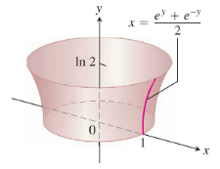 









***Exercise***

The population of a town with a 2010 population of 90,000 grows at a rate of 2.4% /yr. In what year will the population coudle its initial value (to 180,000)?

***Solution***









It reaches 180,000 around the year 2039.

***Exercise***

How long will it take an initial deposit of $1500 to increase in value to $2500 in a saving account with an APY of 3.1%? Assume the interest rate reamins constant and no additional deposits or withdrawals are made.

***Solution***





 



***Exercise***

The number of cells in a tumor doubles every 6 weeks starting with 8 cells. After how many weeks doses the tumor have 1500 cells?

***Solution***





 



***Exercise***

According to the 2010 census, the U.S. population was 309 million with an estimated growth rate of 0.8% /*yr*.

1. Based on these figures, find the doubling time and project the population in 2050.
2. Suppose the actual growth rate is just 0.2 percentage point lower than 0.8% /*yr* (0.6%). What are the resulting doubling time and projected 2050 population? Repeat these calculstions assuming the growth rate is 0.2 percentage point higher than 0.8% /yr.
3. Comment on th sensitivity of these projections to the growth rate.

***Solution***

1. 



The population in 2050:





1. If the growth rate is 0.6%:





The population in 2050:





If the growth rate is 1%:





The population in 2050:





1. A growth rate of just 0.2% produces large differences in population growth.

***Exercise***

The homicide rate decreases at a rate of 3%/yr in a city that had 800 homicides /yr in 2010. At this rate, when will the homicide rate reach 600 homicides/yr?

***Solution***

The homicide rate is modeled by: 





 



So it should achieve this rate in 2019.

***Exercise***

A drug is eliminated from the body at a rate of 15% /hr. after how many hours does the amount of drug reach 10% of the initial dose?

***Solution***





 



***Exercise***

The mass of radioactive material in a sample has decreased by 30% since the decay began. Assuming a half-life of 1500 *years*, how long ago did the decay begin?

***Solution***













***Exercise***

Growing from an initial population of 150,000 at a constant annual growth rate of 4%/*yr*., how long will it take a city to reach a population of 1 million?

***Solution***

 





***Exercise***

A savings account advertises an annual percentage yield (APY) of 5.4%, which means that the balance in the account increases at an annual growth rate of 5.4%/*yr*.

1. Find the balance in the account for  with an initial deposit of $1500, assuming the APY remains fixed and no additional deposits or withdrawals are made.
2. What is the doubling time of the balance?
3. After how many years does the balance reach $5,000?

***Solution***

1. Balance 



1. 



1. 



***Exercise***

A large die-casting machine used to make automobile engine blocks is purchased for $2.5 *million*. For tax purposes, the value of the machine can be depreciated by 6.8% of its current value each year.

1. What is the value of the machine after 10 *years*?
2. After how many years is the value of the machine 10% of its original value?

***Solution***

1. 

 









1. 



***Exercise***

Roughly 12,000 Americans are diagmosed with thyroid cancer every year, which accounts for 1% of all cancer cases. It occurs in women three times as frequency as in men. Fortunately, thyroid cancer can be treated successfully in many cases with radioactive iodine, or I-131. This unstable form of iodine has a half-life of 8 days and is given in small doses meansured in millicuries.

1. Suppose a patient is given an initial dose of 100 millicuries. Find the function that gives the amount of I-131 in the body after  days.
2. How long does it take the amount of I-131 to reach 10% of the initial dose?
3. Finding the initial dose to give a particular patient is a critical calculation. How does the time reach 10% of the initial dose change if the initial dose is increased by 5%?

***Solution***

1.  

After *t* days would be:  millicuries.

1. 



1. 



***Exercise***

City ***A*** has a current population of 500,000 people and grows at a rate of 3% /*yr*. City ***B*** has a cuurent population of 300,000 and grows at a rate of 5%/*yr*.

1. When will the cities have the same population?
2. Suppose City ***C*** has a current population of  and a growth rate of . What is the relationship between  and *p* such that the Cities ***A*** and ***C*** have the same population in 10 years?

***Solution***

1. 











1. 







***Exercise***

Suppose the acceleration of an object moving along a line is given by , where *k* is a positive constant and *v* is the object’s velocity. Assume that the initial velocity and position are given by  and , respectively.

1. Use  to find the velocity of the object as a function of time.
2. Use  to find the position of the object as a function of time.
3. Use the fact that  (by the *Chain Rule*) to find the velocity as a function of position.

***Solution***

1. If 



 Since 









1. 



 Since 





1. 







 Since 



***Exercise***

On the first day of the year , a city uses electricity at a rate of 2000 *MW*. That rate is projected to increase at a rate of 1.3% per *year*.

1. Based on these figures, find an exponential growth function for the power (rate of electricity use) for the city.
2. Find the total energy (in MW-*yr*) used by the city over four full years beginning at 
3. Find a function that gives the total energy used (in MW-*yr*) between  and any future time 

***Solution***

1. 

At a rate of 1.3% per year:





1. 





1. 





***Exercise***

Two points *P* and *Q* are chosen randomly, one on each of two adjacent sides of a unit square.

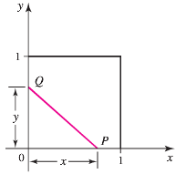

What is the probability that the area of the triangle formed by the sides of the square and the line segment *PQ* is less than one-fourth the area of the square? Begin by showing that *x* and *y* must satisfy  in order for the area consition to be met. Then argue that the required probability is  and evaluate the integral.

***Solution***

The area of the triangle is 

If , then if we let  we have 

Because there is a probability of  of choosing , the probability we seek is at least .

In addtion, for , if ,







***Exercise***

You are under contract to build a solar station at ground level on the east-west line between the two buildings. How far from the taller building should you place the station to maximize the number of hours it will be in the sun on a day when passes directly overhead? Begin by observing that



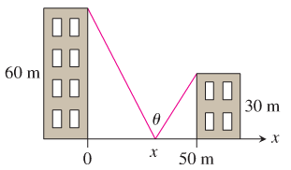

Then find the value of *x* that maximizes *θ*.

***Solution***





















To maximize angle *θ* the distance 

***Exercise***

A round underwater transmission cable consists of a core of copper wires surrounded by nonconducting insulation. If *x* denotes the ratio of the radius of the core to the thickness of the insulation, it is known that the speed of the transmission signal is given by the equation . If the radius of the core is 1 *cm*, what insulation thickness *h* will allow the greatest transmission speed?

***Solution***

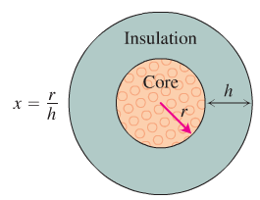









|  |  |
| --- | --- |
| 0 | |
|  |  |

The greatest transmission speed at .







***Exercise***

A commonly used distribution in probability and statistics is the log-normal distribution. (If the logarithm of a variable has a normal distribution, then the variable itself has a log-normal distribution.) the distribution function is



Where  has zero mean and standard deviation 

1. Graph *f* for . Based on your graphs, does  appear to exist?
2. Evaluate . (*Hint*: Let )
3. Show that *f* has a single local maximum at 
4. Evaluate  and express the result as a function of .
5. For what value of  in part (*d*) does  have a minimum?

***Solution***

1. For 

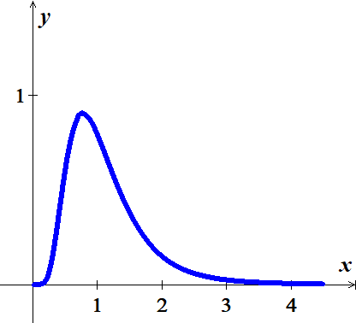

For 

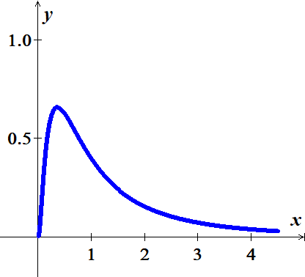

For 

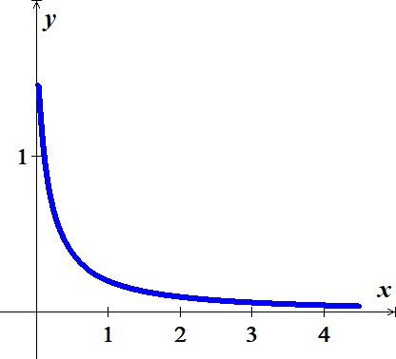



1. Let 

As 







1. 







 Yields to a maximum point.

1. 







1. 





Since 

|  |  |
| --- | --- |
| 0 1 ∞ | |
| − | + |

∴ *g* is decreasing on 

*g* is increasing on 

So, *g* has a *minimum* at 

***Exercise***

Let  be an arbitrary quadratic function and choose two points  and . Let  be the line tangent to the graph of *f* at the point  and let  be the line tangent to the graph at the point . Let  be the vertical line through the intersection point of  and . Finally, let  be the region bounded by , , and the vertical line , and let be the region bounded by , , and the vertical line .

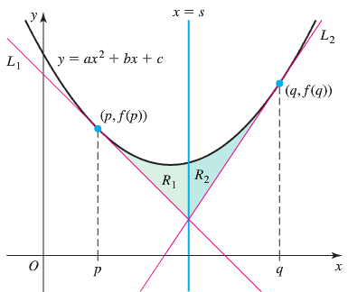

Prove that the area of  equals the area of 

***Solution***





At 



Line 







Line 

At 









If , then 







































